**Lab Report No: 01**

**Name of the lab report: Installing Linux**

**Name: Binodon**

**ID: IT-17046**

**Objective:** In this lab we see the linux installation process

**Installing Linux**

Let's look the various methods we can use to install Ubuntu.

**Installing Linux using USB stick**

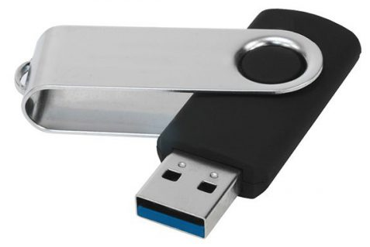

This is one of the easiest methods of installing Ubuntu or any distribution on your computer. Follow the steps.

**Step 1)** Download the .iso or the OS files on your computer from this [link](http://www.ubuntu.com/download/desktop).

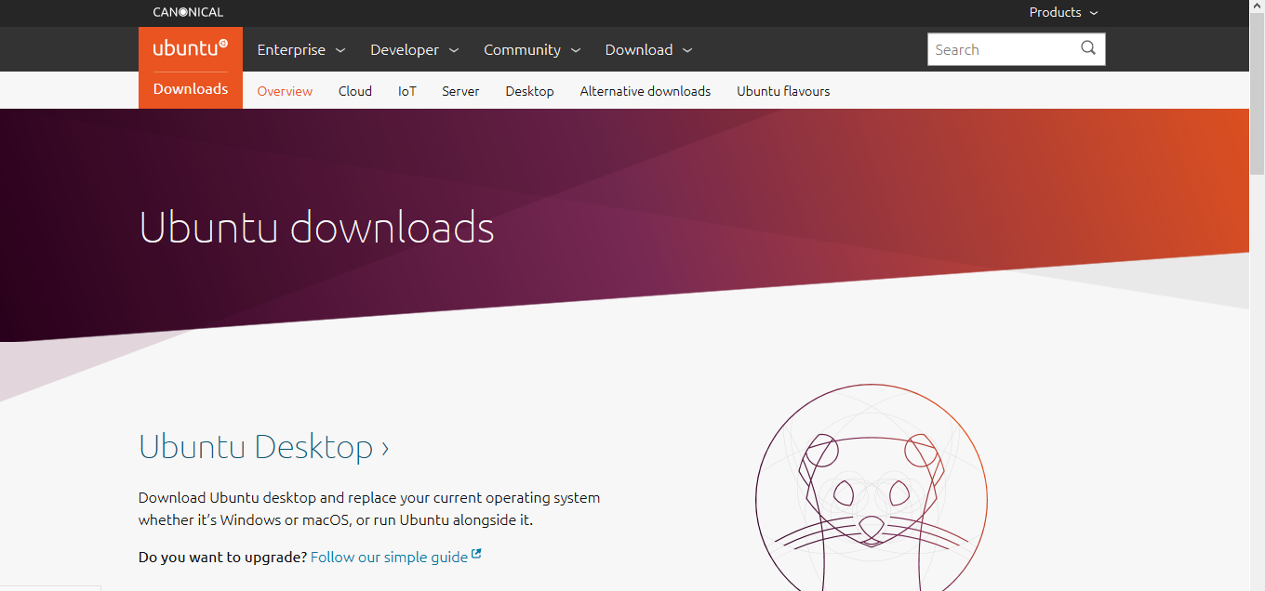

**Step 2)** Download free software like '[Universal USB installer](http://www.pendrivelinux.com/universal-usb-installer-easy-as-1-2-3/) to make a bootable USB stick.

[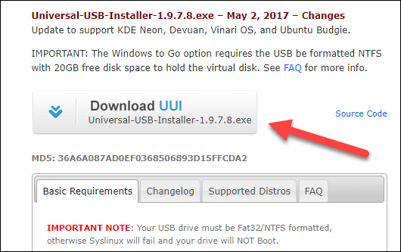](https://www.guru99.com/images/2-2017/092017_0628_HowtoDownlo14.png)

**Step 3)**Select an Ubuntu Distribution form the dropdown to put on your USB

Select your Ubuntu iso file download in step 1.

Select the drive letter of USB to install Ubuntu and Press create button.

[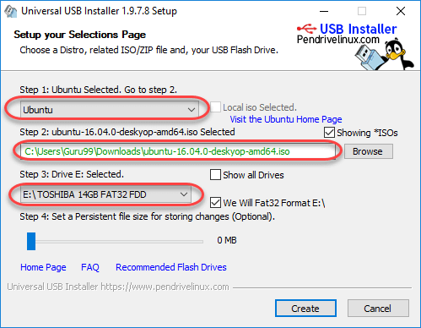](https://www.guru99.com/images/2-2017/092017_0628_HowtoDownlo15.png)

**Step 4)**Click YES to Install Ubuntu in USB.

[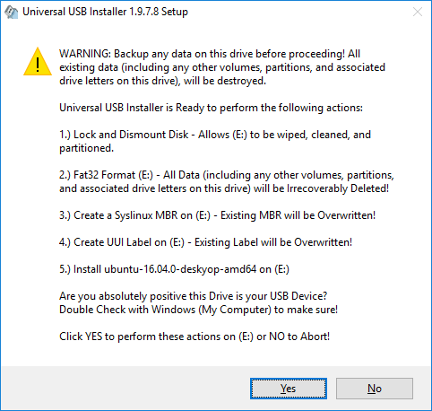](https://www.guru99.com/images/2-2017/092017_0628_HowtoDownlo16.png)

**Step 5)**After everything has been installed and configured, a small window will appear Congratulations! You now have Ubuntu on a USB stick, bootable and ready to go.

[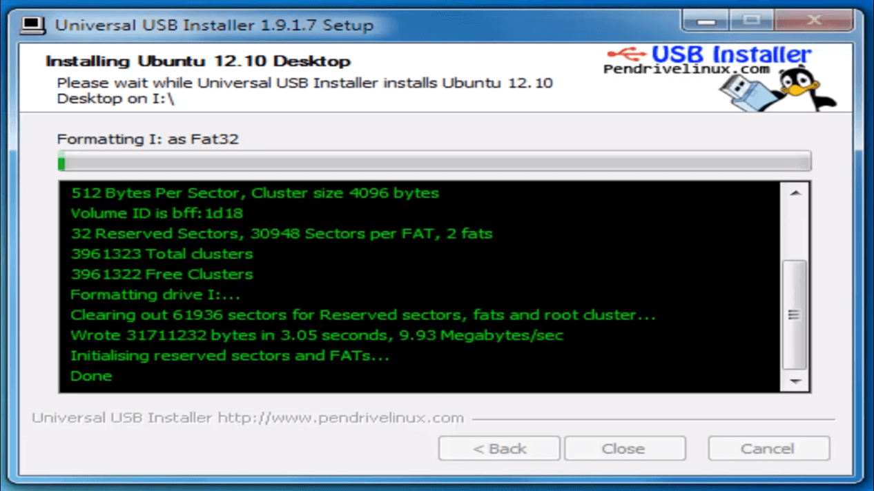](https://www.guru99.com/images/2-2017/092017_0628_HowtoDownlo17.png)

**Step-6**You have an option to Run Ubuntu WITHOUT installing. In this tutorial will install Ubuntu

[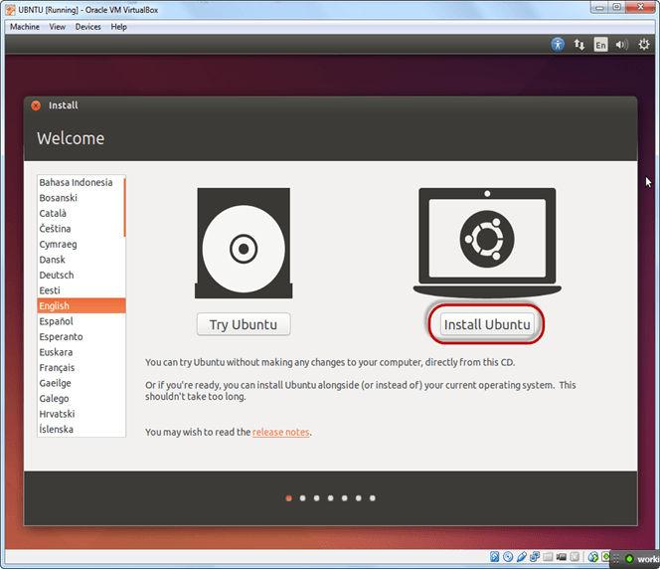](https://www.guru99.com/images/Big_Data/061114_1146_Ubuntuinsta22.png)

**Step-7)** Click continue.

[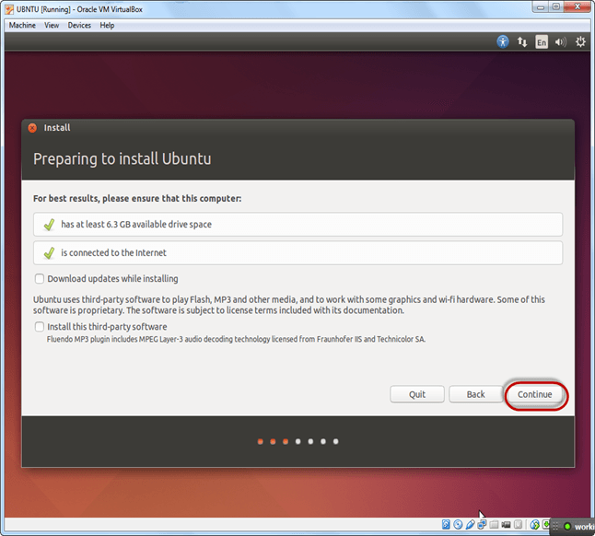](https://www.guru99.com/images/Big_Data/061114_1146_Ubuntuinsta23.png)

**Step-8**Select option to erase the disk and install Ubuntu and click on install now. This option installs Ubuntu into our virtual hard drive which is we made earlier. It will not harm your PC or Windows installation

[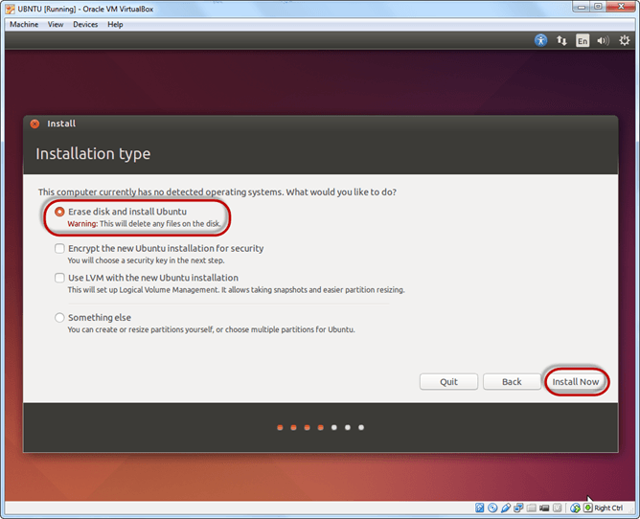](https://www.guru99.com/images/Big_Data/061114_1146_Ubuntuinsta24.png)

**Step-9**Select your location for setting up time zone, and click on continue

[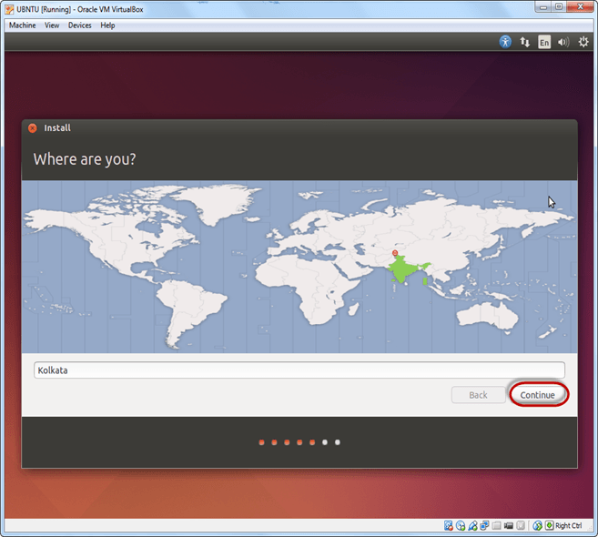](https://www.guru99.com/images/Big_Data/061114_1146_Ubuntuinsta25.png)

**Step-10**Select your keyboard layout, by default English (US) is selected but if you want to change then, you can select in the list. And click on continue

[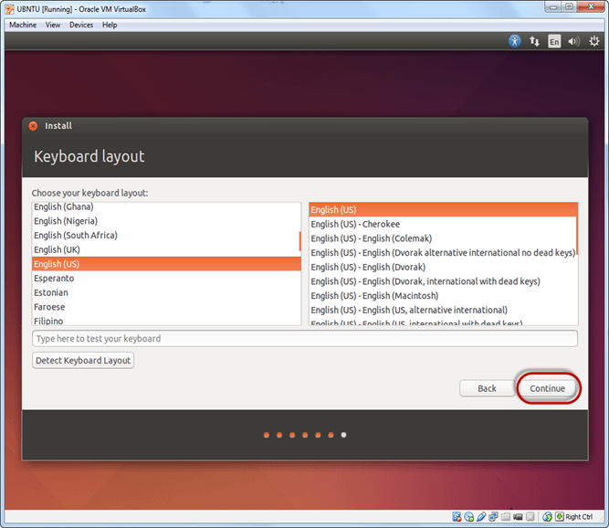](https://www.guru99.com/images/Big_Data/061114_1146_Ubuntuinsta26.png)

**Step-11**Select your username and password for your Ubuntu admin account. This information has been needed for installing any software package into Ubuntu and also for login to your OS. Fill up your details and tick on login automatically to ignore login attempt and click on continue

**Step-12**Installation process starts. May take up to 30 minutes. Please wait until installation process completes.

[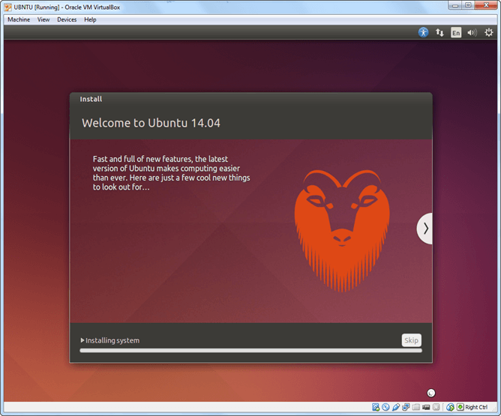](https://www.guru99.com/images/Big_Data/061114_1146_Ubuntuinsta28.png)

**Step-13**After finishing the installation, you will see Ubuntu Desktop.

[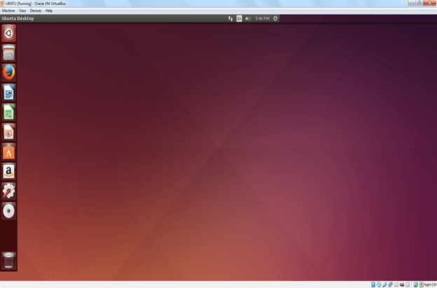](https://www.guru99.com/images/Big_Data/061114_1146_Ubuntuinsta29.png)